Employee Referral Bonus

If you refer a friend or family member to work at Camtu’s Alaska Wild Seafoods, you may be eligible for a referral bonus.

- You do not have to be an employee at Camtu’s Alaska Wild Seafoods to receive the referral bonus.
- You can refer as many applicants as you want.
- Referral bonus payouts will be at the end of the season in September.

ANY APPLICANT THAT YOU REFER WILL BE $200.00 PER REFERRAL BUT MUST SATISFY REFERRAL CONDITIONS.

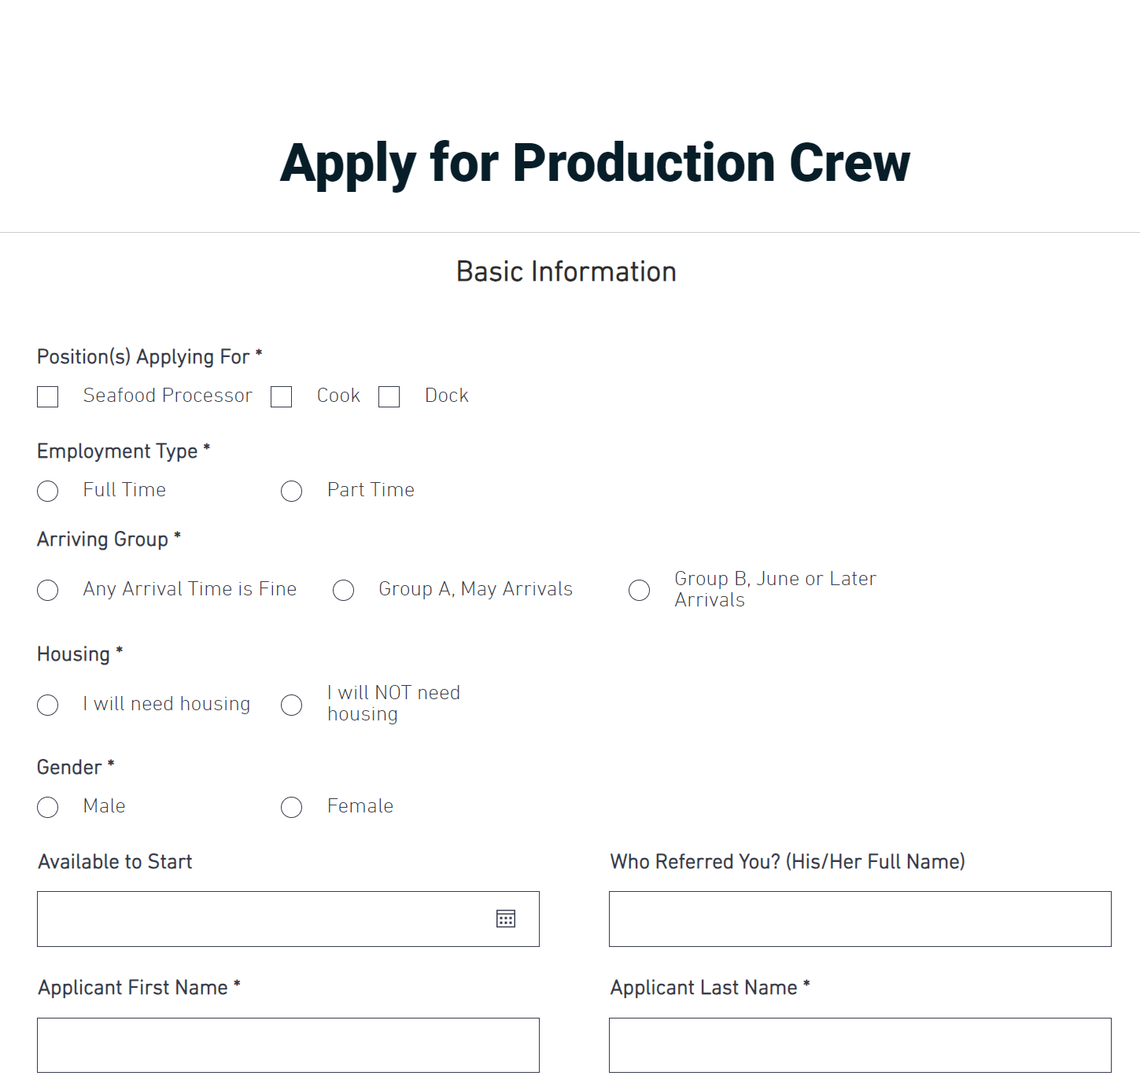
The referral bonus conditions are as follows:

- They must apply on our online application and go through the hiring process. They must put your full name under “Who Referred You” on the application page in the box provided.
- They must arrive and work at Camtu’s Alaska Wild Seafoods for at least 3 months. Eligibility may be sooner if they do not violate any major company policies during their stay.

